www.vanj.com
November 16, 2010
Greg Olsen, President, GHO Ventures
Marriott Hanover, 1401 Rt. 10 East, Whippany, NJ Phone: 973-538-8811
https://www.marriott.com/hotels/maps/travel/ewrho-hanover-marriott/
Registration 11:30, Luncheon 12:00 noon – 2:00 PM

From Entrepreneurship to Spaceship

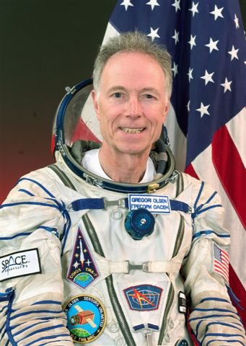
Greg Olsen was the third private citizen to orbit the earth on the International Space Station (ISS). After training for five months (900 hours) at the Yuri Gagarin Cosmonaut Training Center in Moscow, he launched on a Russian Soyuz rocket TMA-7 on October 1, 2005 with Cosmonaut Valeri Tokarev and Astronaut Bill McArthur (Expedition 12). He then docked to the ISS on October 3, and returned to earth on Soyuz TMA-6 on October 11 with Cosmonaut Sergei Krikalev and Astronaut John Phillips (Expedition 11). He performed more than 150 orbits of the earth and logged almost 4 million miles of weightless travel during his 10 days in space.

After an illustrious career as a research scientist and entrepreneur, Greg is now president of GHO Ventures in Princeton, NJ where he manages his “angel” investments. Greg received a BS Physics (1966), a BSEE and MS Physics (1968) from Fairleigh Dickinson University, then was awarded a Ph.D. in Materials Science from the University of Virginia (1971). Greg founded EPITAXX, a fiber-optic detector manufacturer in 1984 together with Vladimir Ban. It was sold in 1990 for $12 million. He then founded Sensors Unlimited, a near-infrared camera manufacturer in 1992 with Marshall Cohen. Sensors was sold to Finisar Corp. for $600 million in 2000, repurchased by the management team in 2002 for $6 million, then sold again to Goodrich, Corp. in 2005 for $60 million.

www.ghoventures.com

Upcoming VANJ Luncheons
Tuesday, December 14, 2010 – Speaker to be Announced

Please pre-register; an attendance list is distributed at the meeting. Use the form below and mail with your check payable to VANJ (charge for members is $35 and $55 for nonmembers), to be received no later than Monday (12 noon) before the meeting to VANJ, 26 Main Street, Chatham, NJ 07928-2402. Telephone reservations are taken only if mail would not be timely. Call Clara Stricchiola at (973) 631-5680, or fax your reservation to (973) 984-9634 / E-Mail: clara@vanj.com. Door Registrations/Late Registrations - $75
------------------------------------------------------------------------------------------------------------------------------------------------------------------

Yes, I will attend the November 16th Luncheon

Your Name: Title:

Company & Type of Industry:

Address City/State/Zip+4 code

Phone: _______ Fax: E-Mail ___________________Amount Enclosed _______________

(Check One) Entrepreneur Investor/Lender Consultant Seeking New Job _____

