www.vanj.com
March 10, 2009

THERE’S GROWTH FUNDING AVAILABLE IN NEW JERSEY!
VANJ Expert Panel Includes Angel, VC Investors & An Alternative Lender
The NJEDA & SBA will explain their grant and credit enhancement programs.

Marriott Hanover, 1401 Rt. 10 East, Whippany, NJ Phone: 973-538-8811
https://www.marriott.com/hotels/maps/travel/ewrho-hanover-marriott/
Registration 11:30; Luncheon 12:00 noon – 2:00 PM

Moderator: Leonard Nuara, Esq., Shareholder, Greenberg Traurig, LLP
Mario Casabona, Investor, Casabona Ventures LLC & Jumpstart NJ
Charles Crockett, Partner, Ascend Venture Group LLC
Jim Kocsi, District Director, SBA
Lori Matheus, Vice President of Regional Business Development, New Jersey Economic Development Authority
Connie Mitchko, Senior Vice President, Medallion Business Credit

These panelists will discuss access to investors, grants, loans and credit enhancements.

Leonard Nuara, Esq. - Leonard Nuara is a shareholder in the Intellectual Property & Technology and Corporate & Securities Departments of Greenberg Traurig's New Jersey office. Leonard focuses his practice on information systems and internet business. He is experienced in the negotiation of license and developmental agreements for emerging technology companies and for established companies. He also handles disputes in licensing, misappropriation of trade secrets, copyright and trademark infringement and anti-competition matters. Leonard's clients include vendors and purchasers of computer and communications systems, and other outsourced services.
Leonard is a nationally recognized author and lecturer about legal matters related to computer technology and is on the advisory and editorial boards of various technology publications.
Mr. Nuara gained the most pertinent experience for his technology practice following the tragic destruction on September 11, 2001 of his prior firm's main office located in the World Trade Center. Fortunately, no employees of the firm perished, but the complete destruction of the twin towers resulted in the loss of essentially all of the firm's technology infrastructure.
On that date, Mr. Nuara interrupted his day to day practice of law and became the CIO of the firm for the following six months. He was responsible for all decisions necessary for the interim survival and ultimate rebuilding of the firm's technology, including:
-Equipment specification and acquisition
-Conversion of the firm's applications palette
-Extensive outsourcing of such IT functions as help desk and infrastructure management.
This experience of being the buyer, instead of being the buyer's "counsel," has given Mr. Nuara valuable technology insight. He frequently speaks on the lessons that he learned from this experience at seminars throughout the U.S. and Europe.


Mario Casabona – Mario Casabona is founder of Casabona Ventures; a New Jersey based Company providing management services, strategic planning, and early stage investment capital to technology driven start-up companies.


Mr. Casabona, in 1982 was the founder and CEO of Electro-Radiation Inc. (ERI) of Fairfield, New Jersey, a developer of Navigation and Communications technology for the Defense Industry. In 2004, ERI was acquired by Honeywell International, where until 2007 he continued to provide management and technical guidance as its Director of Electronic Protection, Defense and Space Systems (D&S) Business Unit in Teterboro, New Jersey.

In 1998, he was awarded the Small Business Administration National Tibbetts Award which recognizes contributions in technology.
Mr. Casabona serves as a Commissioner on the New Jersey Commission on Science and Technology. He is the Chairman of Jumpstart NJ Angel Network, Board member of the New Jersey AOC Chapter (a national defense industry association), Chairman Emeritus of the Research and Development Council of New Jersey, appointed by former Governor James E. McGreevey to the Jobs Growth and Economic Development Commission, and serves on the Technology Advisory Board of the New Jersey Economic Development Authority Edison Innovation Fund. He is also on the advisory board of Fairleigh Dickinson University Rothman Institute for Entrepreneurial Studies, Stevens Institute of Technology Environmental Entrepreneurship Lab, Seton Hall University Entrepreneurial Studies, and the Meadowlands Business Accelerator. He is a member of NJTC, IEEEE, and VANJ. Mr. Casabona also serves on private Company Boards.

Mr. Casabona is a graduate of Fairleigh Dickinson University. He holds 12 national and international patents - with 6 pending - in the field of Satellite based Navigation and Communications.


Charles Crockett – Charles is a Co-Founder and Partner of the Ascend Venture Group, a venture capital firm headquartered in New York City that targets investment opportunities in the applied technology and for-profit education industries. He was responsible for Ascend’s investments in several datacenter infrastructure companies including Snap Appliance (sold to NASDAQ: ADPT), Netilla Networks (sold to AEP Networks) and GridApp Systems. In addition, Charles led investments in a variety of technology enabled services companies including SafeRent (sold to NYSE: FAF), Tripology and Send Word Now.

Before co-founding Ascend, Charles was a Director with The Beacon Group, a $2 billion private equity firm. Charles started his career in the Structured Finance Group at Goldman, Sachs & Co.

Charles received his JD from Stanford Law School and his BS from the Wharton School at the University of Pennsylvania. Charles is a currently a member of the Board of Directors of the New York Software Industry Association (NYSIA), the Board of Visitors of Stanford Law School and the Alumni Leadership Committee of the University of Chicago Laboratory Schools.

Jim Kocsi - James A. Kocsi, district director of the U.S. Small Business Administration's Newark office, directs the SBA’s assistance to the 779,000 small businesses in NJ through the agency’s financial and business development programs. He has oversight responsibilities for eleven Small Business Development Centers administered by Rutgers University, two SBA funded Women’s Business Centers and nine chapters of SCORE. Under Jim’s leadership, the office has consistently provided record levels of support to NJ’s small business owners.
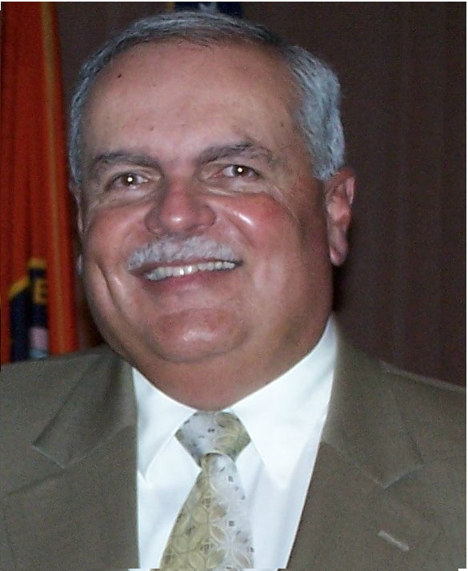

Jim began his SBA career in 1976 as a loan officer in the Newark office, in 1983, he joined the SBA’s NY regional team for government contracting programs, in 1991 he became the Assistant Regional Administrator for Procurement Assistance and from 1993 to 1995, he served as the Area Director for the SBA’s Northeastern government contracting programs and in 1995, he returned to the NJ district office as the deputy district director and was appointed to his current position in January 2001.

Jim is a graduate of the University of Scranton with a B.S. degree in business management and has completed numerous courses in financial management and federal contracting. He is a member of the Federal Executive Board of Northern NJ, the Federal Managers Association, the Reserve Officers Association and is lifelong resident of NJ.

Lori Matheus - Lori Matheus is Vice President of Regional Business Development for the New Jersey Economic Development Authority. In this position, she is responsible for developing and executing the strategic plan for business development and manages key statewide initiatives. The EDA is a self-supporting, independent state agency whose mission is to stimulate business development, job creation and community revitalization throughout the State. The EDA promotes economic growth through financing assistance, technical support and real estate development activities.


Prior to joining the EDA in 2006, she served as Chief Operating Officer for New Jersey Community Capital, a nonprofit corporation and certified community development financial institution that provides capital and consulting services supporting community and economic development. She was responsible for maintaining financial and administrative controls throughout the organization as well as overseeing business and resource development efforts.

She began her financial career in 1990 as a financial analyst with Chemical Bank New Jersey and through a merger, joined PNC Bank as a Vice President in 1996. While at PNC, she held various positions including government banking, community development, finance and administration and retail responsibilities during her seven-year tenure.

She is a graduate of Rider University, where she earned a B.S. degree in finance.

Connie Mitchko – Connie is Senior Vice President at Medallion Business Credit. Medallion Business Credit was formed in 1998 to provide asset based commercial loans to businesses located in the New York/New Jersey metropolitan area. Medallion Business Credit will consider lending opportunities that range in size from $500,000 to $5.0 million. In general, loan advances are based on a formula that takes into account the value of the borrower's accounts receivable and inventory.

Upcoming VANJ Luncheons
April 21, 2009 – Speaker to be Announced
May 29, 2009 – Spring Entrepreneurs Expo & Elevator Pitch Olympics –
Entrepreneurs Register Now to Exhibit & Pitch

Please pre-register; an attendance list is distributed at the meeting. Use the form below and mail with your check payable to VANJ (charge for members is $35 and $55 for nonmembers), to be received no later than Monday (12 noon) before the meeting to VANJ, Box 1982, Morristown, NJ 07962-1982. Telephone reservations are taken only if mail would not be timely. Call Clara Stricchiola at (973) 631-5680, or fax your reservation to (973) 984-9634 / E-Mail: clara@vanj.com. Door Registrations/Late Registrations - $75
----------------------------------------------------------------------------------------------------------------------------------------------------------------

Yes, I will attend the March 10th Luncheon

Your Name: Title:

Company & Type of Industry:

Address City/State/Zip+4 code

Phone: _______ Fax: E-Mail ___________________Amount Enclosed _______________

(Check One) Entrepreneur Investor/Lender Consultant Seeking New Job _____

