www.vanj.com

February 16, 2010
David Drahms, Vice President – Osage Partners
Marriott Hanover, 1401 Rt. 10 East, Whippany, NJ Phone: 973-538-8811
https://www.marriott.com/hotels/maps/travel/ewrho-hanover-marriott/
Registration 11:30; Luncheon 12:00 noon – 2:00 PM

Raising the Series A Round

David joined Osage in 2005 and is involved in several venture organizations, including the MAC Alliance, Early Stage East and the 3 Rivers Venture Fair. Prior to Osage, he worked at Teradyne, Inc., a Boston-based manufacturer of semiconductor test equipment, where he was a mechanical engineer before becoming a project manager.
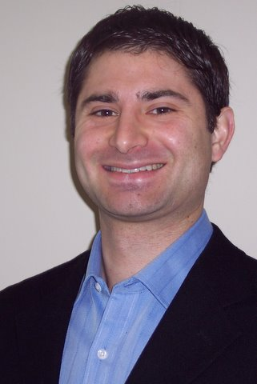

David led the firm's investment in Yaupon Therapeutics, where he serves on the company's Board of Directors. He is also a board observer of FieldView, InstaMed, Melior Discovery, HardMetrics and ProtonMedia.

He is a native of Savannah, NY, and graduated with a degree in Mechanical Engineering from the University of Rochester and an MBA from The Wharton School.

David resides in Philadelphia, PA.

About Osage Partners
Osage Partners is a leading provider of venture capital to early stage technology and healthcare companies in the Mid-Atlantic region. Initial investments range from $1-2 million. Additional information is available at www.osagepartners.com.

Upcoming VANJ Luncheons
Tuesday, March 23, 2010 – David N. Feldman, Esq., Author & Managing Partner, Feldman LLP
Topic: Reverse Mergers and Other Alternatives to Traditional IPOs
Tuesday, April 20, 2010 – Speaker to be announced
Monday, May 24, 2010 – Spring Entrepreneurs Expo & Elevator Pitch Olympics
Tuesday, June 15, 2010 – Speaker to be announced
Tuesday, July 20, 2010 – Speaker to be announced

Please pre-register to be included in the contact/attendance list. Complete this form and mail with your check payable to VANJ (charge for members is $35 and $55 for nonmembers), must be received no later than Monday (12 noon) before the meeting to VANJ, Box 1982, Morristown, NJ 07962-1982. Telephone reservations are taken only if mail would not be timely. Call Clara Stricchiola at (973) 631-5680, fax to (973) 984-9634 or
E-Mail: clara@vanj.com. Door Registrations/Late Registrations - $75
------------------------------------------------------------------------------------------------------------------------------------------------------------------
Yes, I will attend the February 16th Luncheon
Your Name: Title:

Company & Type of Industry:

Address City/State/Zip+4 code

Phone: _______ Fax: E-Mail ___________________Amount Enclosed _______________

(Check One) Entrepreneur Investor/Lender Consultant Seeking New Job _____

