VANJ’S 2010 Spring Entrepreneurs Expo

Elevator Pitch Olympics

Monday, May 24, 2010
Marriott Hanover
1401 Rt. 10 East, Whippany, NJ

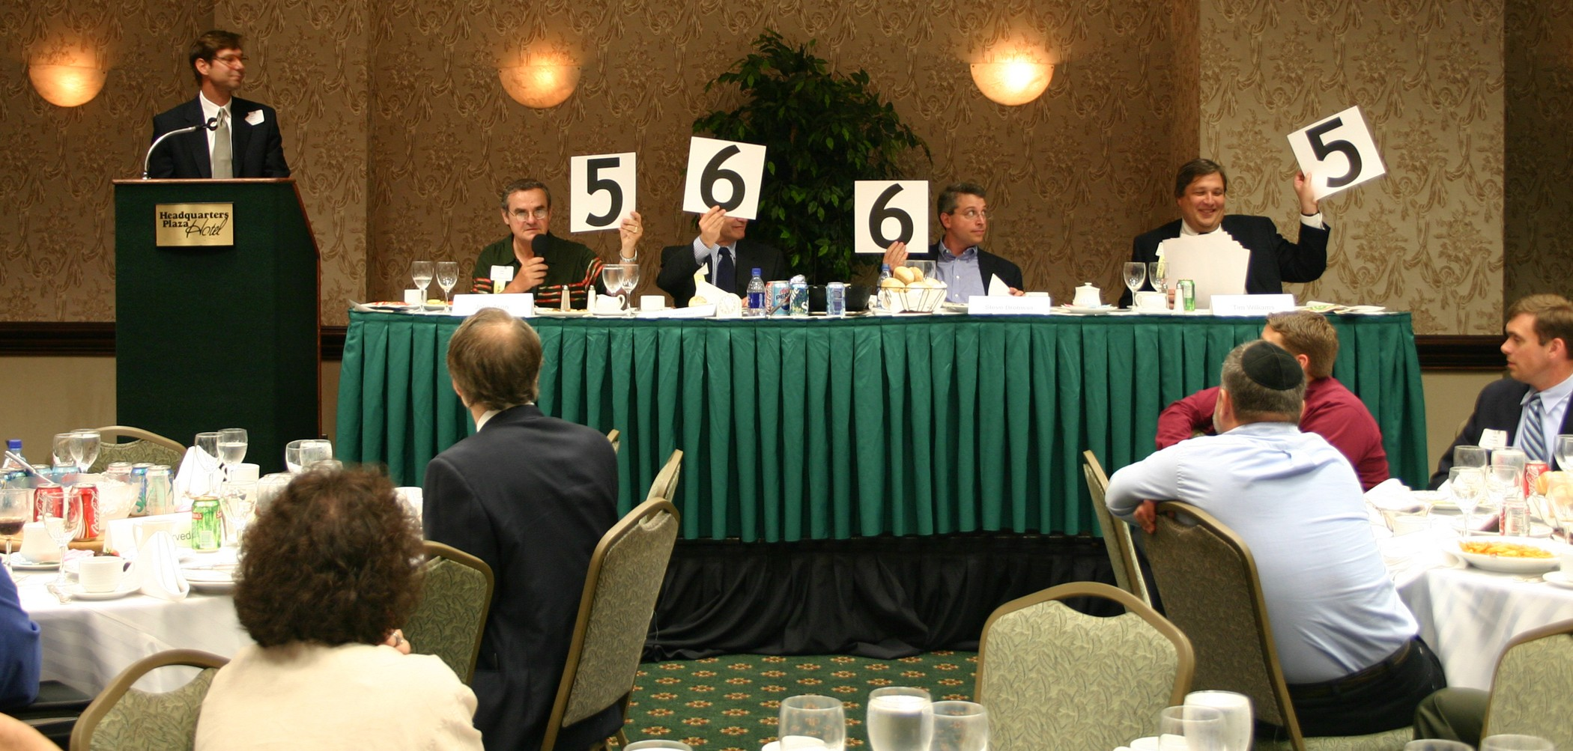
Take advantage of this opportunity to network with venture capital firms, angel investors, early stage startup companies, professional service providers, entrepreneurs and corporate licensing and strategic partnering executives.

Learn more about investing, corporate partnering, and technology licensing and acquisition opportunities.

At 10:00 AM the exhibit hall opens and as many as 35 companies that are seeking capital showcase their companies. At noon the luncheon program begins with our investor panel that focuses on the best ways for early stage companies to attract growth capital from angel or venture capital investors. The day’s luncheon program ends with the Elevator Pitch Olympics from 1:30 – 3:00 PM. The exhibits will open up again at 3:00 PM – 4:00 PM for further networking.

An elevator pitch is a short presentation made by an entrepreneur raising money for a venture. The term describes a pitch that’s short enough that it could be given during an elevator ride when the entrepreneur has the only chance to talk with a potential investor. Just as in the real Olympics, the investor judges hold up their scores and give points ranging from one to ten in the categories of quality of presentation and business fundability.

Marquee Sponsors

Greenberg Traurig, LLP

NJBIZ

Trien Rosenberg

Sponsor
NJ Economic Development Authority

Bag Sponsor
Italian Trade Commission

Morning Coffee Sponsor

Silicon Valley Bank

Supporting Organizations
Connecticut Venture Group
Enterprising Solutions Inc.
Foundations Business
Development Group
NJSBDC
NJBIN
NJIT Enterprise Development Center
NJEF.org Entrepreneurs University
New Jersey Technology Council
Pennsylvania Angel Network
Silicon Garden Angels +
Investors, NJ Angels.net
Rothman Institute of Entrepreneurial Studies
Upstate Venture Association of NY (UVANY)

Investors
Efficiently invest your time to visit entrepreneur exhibits and hear the elevator pitches at one event.

Entrepreneurs
Network with Investors and learn from other entrepreneurs exhibits and elevator pitches.

Panelists & Elevator Pitch Olympic Judges
Moderator – Leonard T. Nuara, Esq., Shareholder,
Greenberg Traurig LLP

Panelists
Michael Helmer, Esq., Shareholder, Greenberg Traurig LLP
Arrun Kapoor, Principal, SJF Ventures
James G. Kollegger, CEO, Genesys Partners, Inc.
Mark Padgett, Managing Partner, Plutus Capital Partners
David Sans, Managing Director, Althia Capital LLP
A. Wayne Tamarelli, Ph.D., Angel Investor, President, AWT Private Investments
Peggy Wallace, Managing Director, Golden Seeds

Monday, May 24, 2010
Marriott Hanover

Westin
9:00 am - 5:00 pm
Westin Hotel, 2 Whippany Road, Morristown, NJ

Company Exhibits 10:00 AM - 12:00 PM
3:00 PM - 4:00 PM

Luncheon Program & 12:00 PM - 3:00 PM

Elevator Pitch Olympics

ATTENDEE REGISTRATION

Company Exhibits and Luncheon Program: Register by mail using the form below. The cost is $75.00 (VANJ Members $50.00). Given the large turnout expected for the luncheon we may not be able to accept door registrations and reservations MUST be prepaid. Register early — last year’s luncheon was oversubscribed. Registrations after May 18th are door registrations and are $100.

View Company Exhibits: $25 - 10:00 AM – 12:00 Noon (Pre-registration Not Required)

For registration complete this form (or attach your business card), attach your check to VANJ for the proper amount and mail to VANJ, Box 1982, Morristown, NJ 07962-1982. Telephone, fax or e-mail reservations are possible, but your registration and payment for the luncheon must be received by Tuesday, May 18th. Please call Clara Stricchiola at 973-631-5680. or fax your registration to 973-984-9634 or email clara@vanj.com. (An attendance roster will be distributed.) Visit www.vanj.com to view pictures from previous events.

Spring 2010 Entrepreneurs Expo & Elevator Pitch Olympics Registration
($75 non-members; $50 members)
Monday, May 24th
(Fill out this form or simply attach your business card)

I will attend the exhibits & luncheon ($75 non-members; $50 members)
(Please note, pitches are given by exhibitors only)
(Door Registrations $100-After Tuesday, May 18th)

Name & Title:

Company:

Address:

City, State, Zip:

Phone: Fax: Email:

Fee: $50 VANJ Members $75 Non-Members

(Circle One) Entrepreneur Investor/Lender Consultant Seeking New Job

