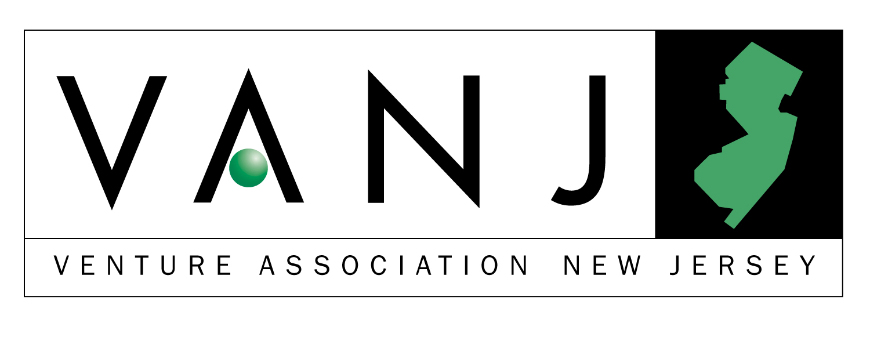
First Annual Entrepreneurs Expo
Monday, May 14, 2001
The Westin Hotel, Morristown, NJ

Exhibits Open 10:00 AM through 4:00 PM

VANJ luncheon 11:30 AM through 2:00 PM

Entrepreneur Expo is an opportunity for emerging companies to display their innovative products or services to an audience of investors and supporters of New Jersey entrepreneurial activity. The Entrepreneur Expo features networking, exhibits, and exposure to representatives from a variety of funding sources including angel investors and early stage venture firms. At our luncheon, a panel of three angel investors and three early-stage venture capitalists will share their war stories of good and bad deals.

- Your opportunity to observe the latest entrepreneurial developments in this region.
- Network with venture capital firms, early stage startup companies, professional service providers, entrepreneurs, angel investors and corporate product planners.

Panel Moderator:
Bernard H. Tenenbaum, President of the Children’s Leisure Products Group (CLP) of The Jordan Company partners with talented entrepreneurial management of companies that make products that parents buy for children, including toys, sporting goods, housewares, candy, jewelry and health and beauty aids. Previously, he was Vice President of Corporate Development of Russ Berrie and Company responsible for the development and implementation of a diversification strategy through the acquisition and subsequent management of entrepreneurial companies that sell to the mass market. Acquisitions were purchased for $34.5 million and later sold to Hasbro for $166 million. Bernie was the founding Director of the George Rothman Institute of Entrepreneurial Studies at Fairleigh Dickinson University, and the first George Rothman Clinical Professor of Entrepreneurial Studies. He previously served as the Associate Director of the Sol C. Snider Entrepreneurial Center of The Wharton School of the University of Pennsylvania, founded the Wharton Small Business Development Center, the largest university-based consulting program for small companies in the United States and taught at The Wharton School for eight years prior to his Rothman appointment. Bernie is a graduate of Columbia College of Columbia University, with a B.A. in English, and did graduate work at Stanford University in Literature and Theatre. He received an MBA in Entrepreneurial Studies from The Wharton School in 1981. Bernie also is a partner or investor in a number of ventures, including a software company, a medical device manufacturer, and a real estate management company.

Panelists:

Frederick J. Beste III has spent his entire 33-year career in the venture capital industry, beginning in 1968 with Greater Washington Investors, Inc., a publicly held venture capital firm, where he was Vice-President and Treasurer. In 1975 he joined Kentucky Highlands Investment Corporation, a private venture capital development firm, where he was Vice-President and, ultimately, President and Chief Executive Officer. He joined MAVF in 1984 as the founding President and Chief Executive Officer of its first general partner. MAVF is comprised of four venture capital limited partnerships totaling approximately $200 million in capital. The funds focus on seed and start-up stage investments, primarily in technology-based companies located in the mid-Atlantic. During the course of his career, Fred has served on the boards of directors of several dozen operating companies and has advised and worked with thousands of entrepreneurs. He has been widely published on the subjects of venture capital and entrepreneurship, and has done extensive public speaking on both subjects as well. He was the Chairman of the 1994 Mid-Atlantic Venture Fair, the largest such event in the industry, and the recipient of the Greater Philadelphia Venture Group’s 1995 Blair Thompson Memorial Award for career achievement. He received his B.A. in Economics from Stetson University.

Ronald R. Hahn is Chairman of the Board and President of ESE Partners, LLC, the General Partner of Early Stage Enterprises, LP (ESE). ESE is a venture capital fund organized to invest in and provide business development assistance to seed and early stage companies. During his thirty-year career, Ron has worked with companies in a number of different industries, sitting on the Boards of Directors of more than thirty companies. He currently serves on the boards of nine portfolio

Trien Rosenberg


Our Marquee Sponsors



companies. His experience also includes organizing public offerings, private placements, and acquisitions. In addition, he has
started a successful business, operated as a crisis manager and consulted to numerous organizations. Later in his career, he founded Princeton-Montrose Partners, LP, a venture capital fund specializing in life science technology. Before founding ESE, he was a Vice President and General Partner of Patricof & Co., a New York based venture capital organization. Ron received his BA degree from Occidental College, and his MBA degree from the Anderson School of Management, University of California, Los Angeles.

Jim Gunton has been investing in or working with high technology companies for nearly fifteen years. Since 1994 he has lead the Edison Venture Fund’s investment efforts in New Jersey, and was recently named a general partner for the NJTD Venture Fund, an early stage venture capital fund focused on financing New Jersey companies. Jim holds degrees from Stanford University and Duke University, where he was the winner of the “Class of 1987” scholarship.

Martin A. Goetz was a founder (in 1959) and former President of Applied Data Research (ADR), a 200 million dollar company that was traded on the N.Y. Stock Exchange prior to its acquisition by Ameritech in 1986. His company was the first company to sell a software product commercially, and it pioneered the start of the Software Products Industry (1965). He received the first U.S. Software Patent in 1968. In 1989 he was elected to the Infomart Computer Hall of Fame along with Bill Gates. He was a leading advocate of software product protection through copyright and patent law, and his leading role in combating unfair competitive practices in software by hardware manufacturers is widely recognized. For the last thirty years through articles and speeches, Goetz has helped promote the status and growth of the independent software industry. Goetz has been a featured speaker at industry and user forums and has written over 50 articles in leading trade publications. He is a co-author of High Level Cobol Programming, published in 1977. Currently, he is a private investor and management consultant to software product firms and venture capital firms.

John Ason is an angel investor specializing in early stage pre-revenue companies. He has made twelve investments in the areas of e-commerce, 3D technology, internet publishing, smart labels, advertising and entertainment/media. John was at AT&T Bell Labs for over 25 years, first involved in software and technology development, then in marketing and business management of large software projects. He is a graduate of the Illinois Institute of Technology.

Gerald Bedrin Starting with a family owned office products company, Jerry first grew sales to 65 million dollars then orchestrated a six company roll-up and with acquisitions grew sales to 300 million. He soon became an angel investor and provided several million dollars to over a dozen companies. His latest venture, in partnership with his wife, is Equity Staffing.

Upcoming Meeting: Tuesday, June 19, 2001
"Managing Knowledge for Competitive Advantage"
Raymond Infante, Sr. Consultant, Microsoft Corporation
Robert Terdeman, Chie Data Warehouse Architect, EMC Corporation

The luncheon portion of our Expo is limited to 300 attendees. To ensure your space, please preregister. Send your check payable to VANJ ($25 members, $75 nonmembers) along with this form to be received no later than May May 7th to: VANJ, Box 1982, Morristown, NJ 07962-1982. Door registration, if available is $100. For further information call 973-267-4200, Ext. 193 or email clara@vanj.com.
NAME : TITLE:

COMPANY:

ADDRESS:

PHONE: FAX: EMAIL:

(Check One) Entrepreneur ____ Investor/Lender ____ Consultant ____ Seeking New Job ____

Yes, I will attend the May 14th Luncheon Program ($75 Non Members, $25 Members)

