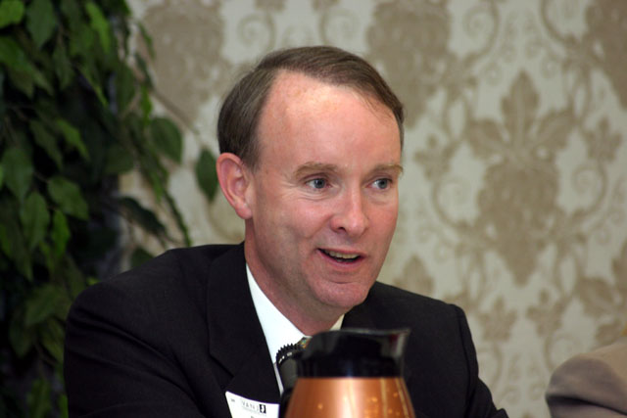
Investor, Dan Flatley, General Partner, Masthead Venture Partners, LLC
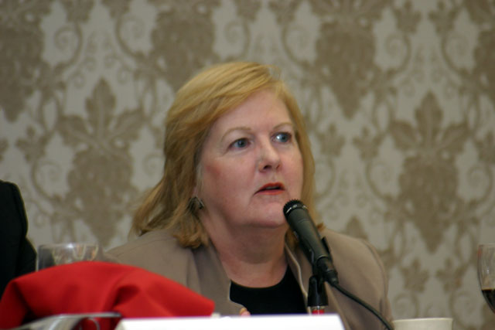
Investor, Katherine O’Neill,
Executive Director, Jumpstart NJ Angel Network

