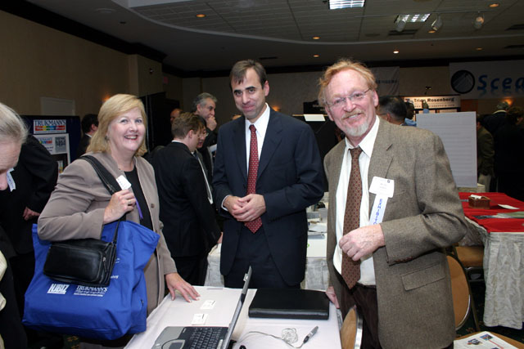
Investor panelist, Katherine O’Neill (Left) with representatives from exhibitor Linguaflex, Inc. Andrew Scirri, (Center), Ira Sanders, MD
Investor panelist, Marc Singer, General Partner, BEV Capital describes his fund’s investment criteria
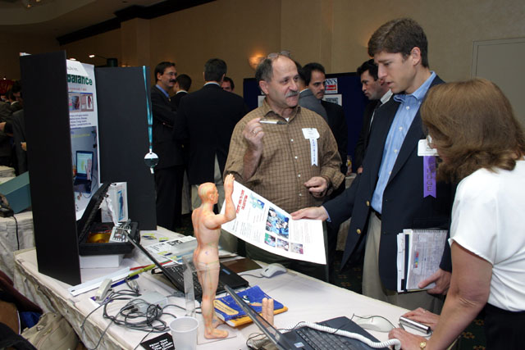
Investor panelist, Marc Singer (Right) with exhibitor
Isaak Shoikhet, VP of Finance/Saes, Vivalife Inc.
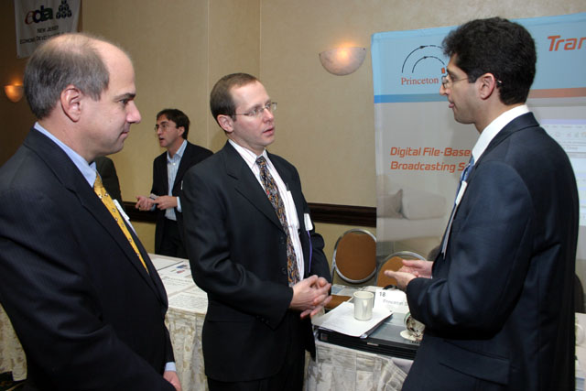
Investor panelist Chris Saxman (Center) talks to Princeton Server Group’s, Steven Georges, CFO (Left) and Jesse Lerman, President & CEO
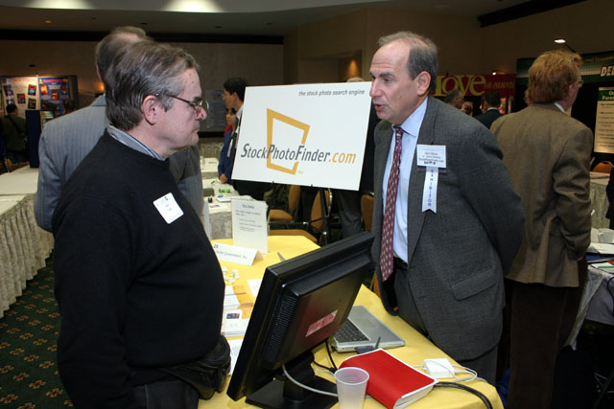
Angel Investor John Ason (Left) with Gary Elsner, VP Sales & Marketing, StockPhotoFinder.com

(Left to Right) Jay Trien, President, VANJ,
Michael Wiley, Project Officer Real Estate, NJEDA, Jeanne Gray, President, NJEntrepreneur.com and Kathleen Coviello, Program Mgr. Science & Technology, NJEDA

