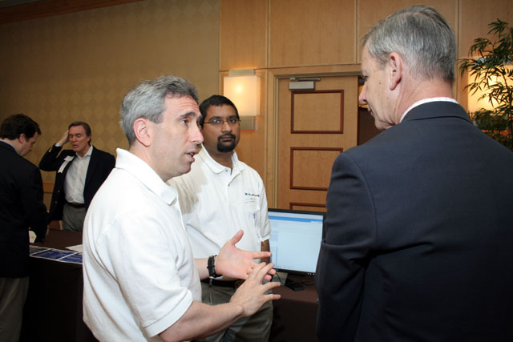
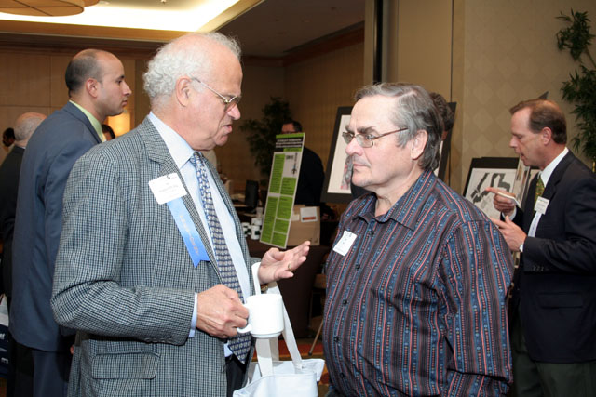

Jay Trien, CPA, Esq. President of VANJ & Senior Partner, Trien Rosenberg and John Ason, Angel Investor
Elevator Pitch Winner, Scott Barnett, President, Bluenog Corp,
Suresh Kuppusamy, Co-Founder, Bluenog Corp. & Investor Panelist, Richard Dumler, Partner, Milestone Venture Partners
Marquee Sponsor, Joseph Bosotina, Regional Sales Consultant, TriNet Total HR Services discusses TriNet’s services with Mike Zufall, Managing Director, JemTel Telecommunications (on Joe’s left) and Doug Brown, CEO/President, Paradigm Associates, LLC

