
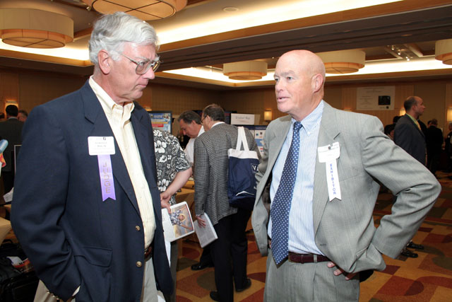
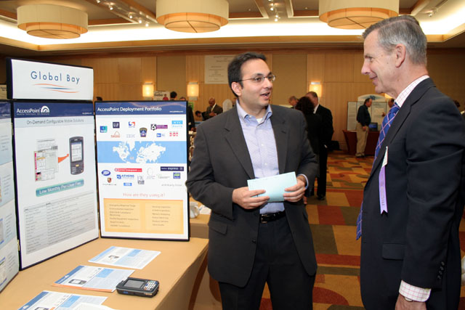
Investor Panelist, Richard Dumler, Partner, Milestone Venture Partners
Investor Panelist, Frederick J. Beste, III, President & CEO, Mid-Atlantic Venture Fund & Exhibitor, Raymond C. Hedger, Jr., President, ePlans
Sandeep Bhanote, CEO, Global Bay & Investor Panelist, Richard Dumler, Partner, Milestone Venture Partners

