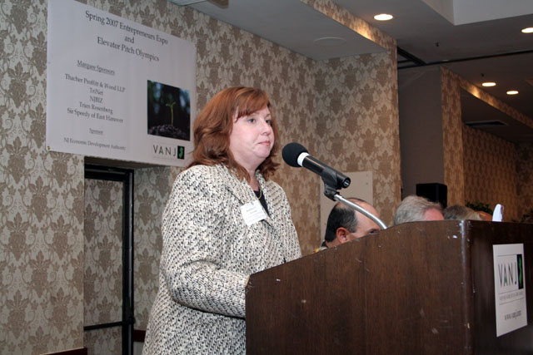
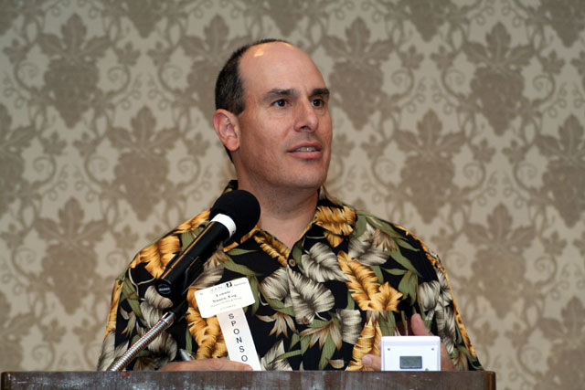
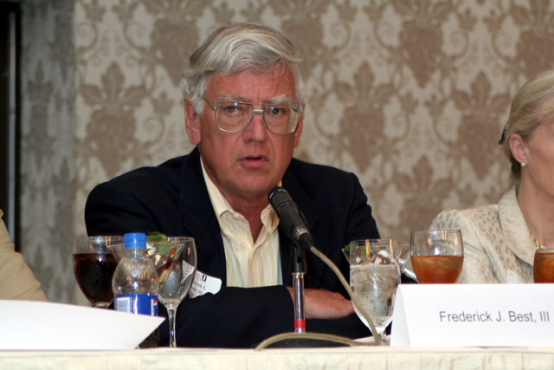
Marquee Sponsor & Moderator, Leonard T. Nuara, Esq., Partner, Thacher Proffitt & Wood
Sponsor, Kathleen Coviello, Program Mgr. – Science & Technology, NJ Economic Development Authority
Investor Panelist, Frederick J. Beste, III, President & CEO, Mid-Atlantic Venture Funds

