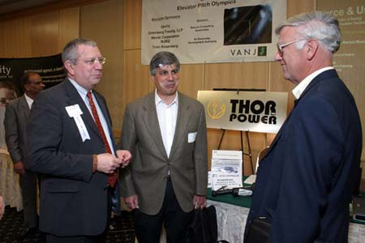
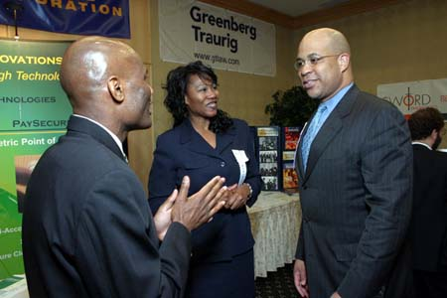
Tyrone Cole, President & CEO, & Pamela J. Martinez, Executive
Vice President, CTO of Global Technical Innovations, Inc.
& Charles Crockett, Ascend Venture Group, LLC
Jean Wilson, Guidelines for Growing Up, Inc., Don Pierson, Pengad, Inc. & Robert Donaldson, Delta Planning
Investor, Charles Crockett, Ascend Venture Group, Investor, Fred Beste, Mid-Atlantic Venture Fund & VANJ President Jay Trien
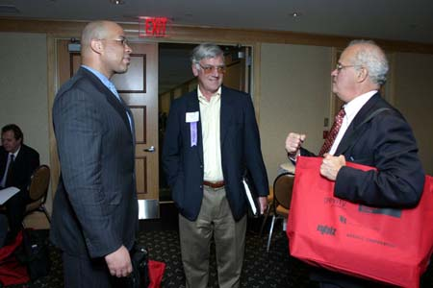
David Bonner, CEO, Thor Power, Lawrence Poster, Catalyx Group & Fred Beste, Mid-Atlantic Venture Funds
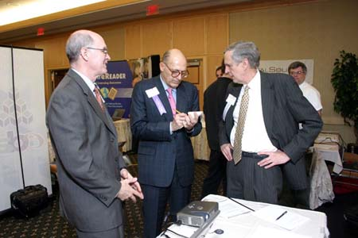
William Dix, SVP Sales, PortfolioSearch, Investor,
Ed Goodman, Milestone Venture Partners & Richard Schwarz, CEO, PortfolioSearch
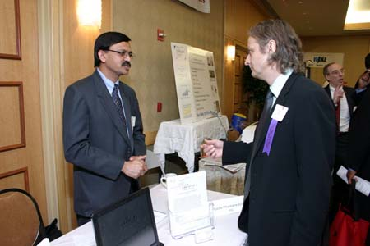
Suresh Borsadia, President & CEO, Abeille Pharmaceuticals
& Angel Investor, Bob Rice

