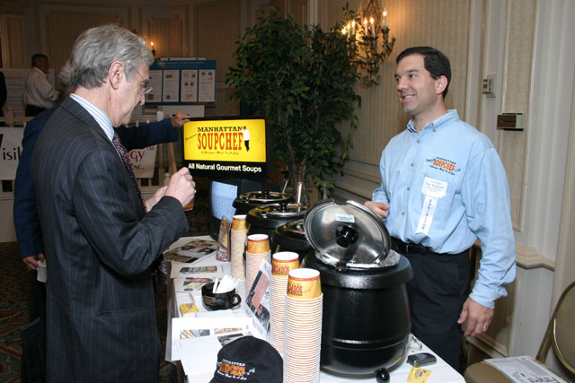
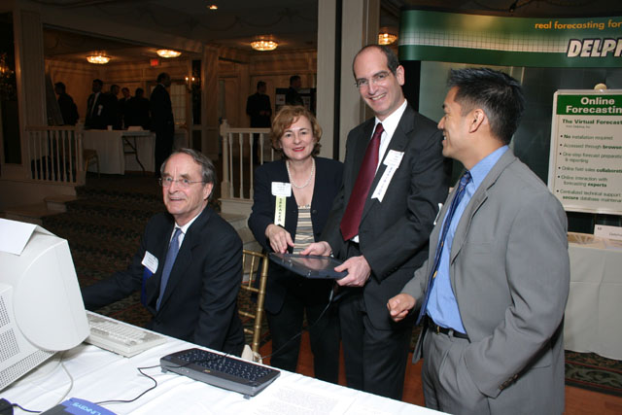


Sunjay Guleria, VP Marketing, Musikube &
John Ason, Angel Investor
Alan Patricof, Vice Chairman of Apax Partners, Inc. &
Dan Rubano, Manhattan Soup Chef
Bob Donaldson, Delta Planning, Jeanne Sullivan, Partner, StarVest Partners, Rick Weiss, President, Viocare Technologies & Roger Aguinaldo, The M&A Advisor
Alan Patricof, Vice Chairman, Apax Partners, Inc. & Amy Sinaiko, Eat Your Heart Out
Innovations In Home Entertainment
Eric Chilipka, Jennifer Ann Coccari, Lisa Bencomo & Ryan Herd
