VANJ’S 2012 Fall
Life Science, HealthCare & Medical Device
Expo & Elevator Pitch Olympics

Monday, November 12, 2012
Hanover Marriott
1401 Rt. 10 East, Whippany, NJ
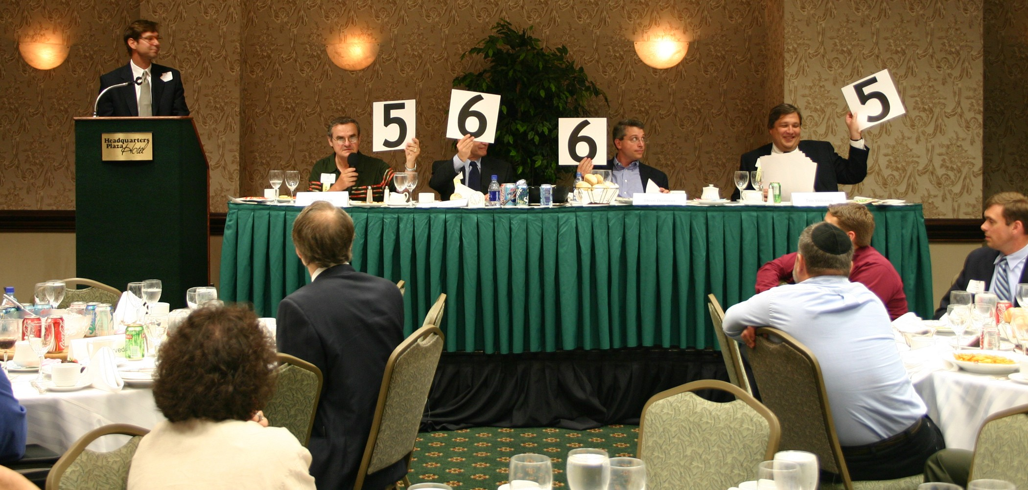

Take advantage of this opportunity to network with venture capital firms, angel investors, early stage startup companies, professional service providers, entrepreneurs and corporate licensing and strategic partnering executives.

Learn more about investing, corporate partnering, and technology licensing and acquisition opportunities.

Marquee Sponsors

Raich Ende Malter & Co. LLP

SorinRand LLP

Provident Bank
Your Connection

PBNY Bank
A division of Provident Bank,
New York

Sponsors

NJ Economic Development Authority

The NY Enterprise Report

Supporting Organizations
Angels + Life Science Investors www.NJAngels.net
Connecticut Venture Group
Entrepreneurs University www.EntreUniv.org
Foundations Business
Development Group
NJSBDC
NJBIN
NJEntrepreneurshipToday
NJIT Enterprise Development Center
NJ Meadowlands Commission
Business Accelerator
New Jersey Technology Council
Pennsylvania Angel Network
Rothman Institute of Entrepreneurship
Upstate Venture Association of NY (UVANY)

At 10:00 AM the exhibit hall opens up to as many as 30 companies that are seeking capital showcase their companies. At noon the luncheon program begins with our investor panel that focuses on the best ways for early stage companies to attract growth capital from angel or venture capital investors. The day's luncheon program ends with the Elevator Pitch Olympics from 1:30 PM - 3:00 PM. The exhibits will open up again at 3:00 PM - 4:00 PM for further networking and meetings with panelists. Attendees learn about investing, corporate partnering, technology licensing and acquisition opportunities.

An elevator pitch is a short presentation made by an entrepreneur raising money. The term describes a pitch that's short enough that it could be given during an elevator ride when the entrepreneur has the only chance to interest a potential investor. Just as in the real Olympics, the investor judges hold up their scores and award points of one to ten in the categories of quality of presentation and business fundability.

Investors
Efficiently invest your time to visit entrepreneur exhibits and hear the elevator pitches at one event.

Entrepreneurs
Network with Investors and learn from other entrepreneurs exhibits and elevator pitches.

Panelists & Elevator Pitch Olympic Judges
Moderator
David J. Sorin, Esq., Managing Partner, SorinRand LLP
Panelists
John K. Clarke, Managing Partner, Cardinal Partners
Rajeev Dadoo, PhD, Partner, SR One
Brenda Gavin, Partner, Quaker Partners
Debbie Hart, President, BioNJ
Martin Kratchman, Managing Partner & Founder, HealthPro BioVentures LLC
Noah J. Kroloff, Partner, NGN Capital
Zev Scherl, General Partner, NewSpring Capital

Monday, November 12, 2012
Hanover Marriott

Westin
9:00 am - 5:00 pm
Westin Hotel, 2 Whippany Road, Morristown, NJ

Company Exhibits 10:00 AM - 12:00 PM
3:00 PM – 3:30 PM

Luncheon Program & 12:00 PM - 3:00 PM

Elevator Pitch Olympics
Investor One on One Sessions 3:00 PM – 4:30 PM

ATTENDEE REGISTRATION

Exhibitor Fee
Before October 5th - $350 - After October 5th - $600

Company Exhibits and Luncheon Program: Register by mail using the form below. The cost is $75.00 (VANJ Members $50.00). Given the large turnout expected for the luncheon we may not be able to accept door registrations and reservations MUST be prepaid. Register early — last year’s luncheon was oversubscribed. Registrations after November 7th are door registrations and are $100.

View Company Exhibits: $25 - 10:00 AM – 12:00 Noon (Pre-registration Not Required)

For registration complete this form (or attach your business card), attach your check to VANJ for the proper amount and mail to VANJ, 26 Main Street, 1st Floor, Chatham, NJ 07928-2402. Telephone, fax or e-mail reservations are possible, but your registration and payment for the luncheon must be received by Wednesday, November 7th . Please call Clara Stricchiola at 973-631-5680. or fax your registration to 973-984-9634 or email clara@vanj.com. (An attendance roster will be distributed.) Visit www.vanj.com to view pictures from previous events.

November 12, 2012 Expo & Elevator Pitch Olympics Registration
($75 non-members; $50 members)
(Fill out this form or simply attach your business card)

I will attend the exhibits & luncheon ($75 non-members; $50 members)
(Please note, pitches are given by exhibitors only)
(Door Registrations $100-After Wednesday, November 7th)

Name & Title:

Company:

Address:

City, State, Zip:

Phone: Fax: Email:

Fee: $50 VANJ Members $75 Non-Members

(Circle One) Entrepreneur Investor/Lender Consultant Seeking New Job

